2nd PEDIATRIC INTERNATIONAL MEETING
  - 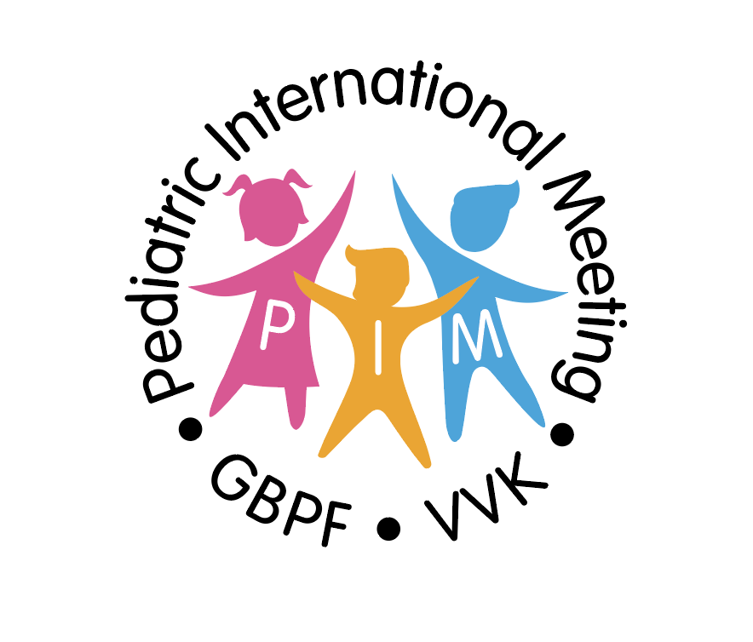

Organized by the GROUPEMENT BELGE DES PEDIATRES DE LANGUE FRANCAISE (G.B.P.F.)

In collaboration with the VLAAMSE VERENIGING VOOR KINDERGENEESKUNDE (V.V.K.)

And in collaboration with the PEDIATRICIANS FROM THE UNITED ARAB EMIRATES

Abu Dhabi the 5th, the 6th and the 7th of FEBRUARY 2020

Wednesday the 5th of february 2020 :
Scientific day

08H30 : Welcome

08H55 : Opening of the scientific sessions
Dr. Jean Evrard – Prof. Dr. Ann De Guchtenaere –Dr. Anna Bael – Dr. Farès Chedid

SESSION 1 : CONTROVERSIAL LINKS
Moderators : Dr. Hishman Tawakol – Dr. Philippe Alliet

09H00 : Hygiene and Allergy ? Prof. Dr. B. Lambrecht
09H30 : Autism and Food ? Prof. Dr. Mohamed Meqdadi
10H00 : Bloated children and food-intolerance ? Dr. Aurélie Lievens
10H30 : Discussion

10H45 : Coffe break

SESSION 2 : TIME TO EAT
Moderators : Prof. Dr. Mohamed Meqdadi – Dr. Pierre Philippet

11H15 : Early enteral nutrition and brain development Dr. Hisham Tawakol
11H35 : Early introduction and allergy ? Prof. Dr. Bruno Hauser
12h05 : Nutritional diversification Prof. Dr. Françoise Smets
12H35 : Discussion

13H00 – 14H00 : Lunch time

SESSION 3 : NEONATAL SESSION
Moderators : Dr. Fares Chedid – Dr. Anna Bael

14H15 : Innovation in neonatal ventilation Dr. Aiman Rahmani
14H45 : Place of the maternal milk in the neonatogist’s practice ? Dr. Anne Vervoort
15H15 : Latest insight on HMO in formula ? Dr. Philippe Alliet
15H45 : Discussion

16H00 : Coffe Break

SESSION 4 : INFLAMMATORY BOWEL DISEASE
Moderators : Dr. Aiman Rahmani – Dr. Aurelie Lievens

16H30 : Radiological perspective of NEC Dr. Fares Chedid
17H00 : Etiology of the bleeding gut ? Dr. Kotilea Kalliroy
17H30 : Nutrition in pediatric inflammatory bowel disease Prof. Dr. Ilse Hoffman
18H00 : Discussion

18H30 : End of the scientific day

Thursday the 6th of February 2020 :
Visit of the hospital

From 09h00 until noon
at the Sheikh Khalifa Medical Center
Guided by Prof. Dr. Mohammed Meqdadi

Friday the 7th of February 2020 :
Symposium GBPF – VVK :
“Pratical aspects of the pediatric nutrition in Belgium”

From 09h00 until noon

