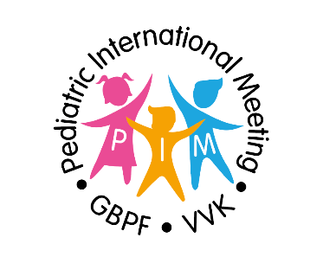
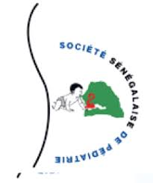

PIM 2023
GBPF - VVK - SOSEPED

SCIENTIFIC PROGRAM

THURSDAY 9 FEBRUARY 2023

Morning Scientific Program : Pediatriccs in Belgium – how to proceed.

Hospital visit : Hospital for sick children Diamniadio
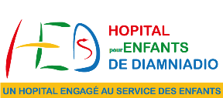

FRIDAY 10 FEBRUARY 2023

08:30 - 09:00 Registration - pick-up your badge

Morning program: Focus on Nutrition

09:00 - 09:30 "Malnutrition in Africa: Snapshot of the situation in Senegal" | Dr. Maty Diagne Camara (Senegal)

09:30 - 10:00 "Junk food and obesity in Belgium and in Western countries" | Dr. Ann De Guchtenaere (Belgium)

10:00 - 10:30 "Diversification: When and how to introduce it ?" | Prof. Françoise Smets (Belgium)

10:30 - 11:00 Coffee break

11:00 - 11:30 "Kangaroo Method: experience of Senegal" | Prof. Modou Gueye (Senegal)

11:30 - 12:00 "Breastfeeding: What promotion strategy in Senegal?" | Prof. Ndèye Ramatoulaye Diagne Gueye (Senegal)

12:00 - 12:30 "Allergy and Food Intolerance" | Dr. Kamal El Abd (Belgium)

12:30 - 13:00 "Gastroesophageal reflux disease: a mainly Western disease ?" | Prof. Yvan Vandenplas (Belgium)

13:00 - 15:00 Lunch break

Afternoon program: Focus on Infections and Imported Diseases

15:00 - 15:30 "Intensive care: experience in Senegal" | Prof. Aliou Thionane (Senegal)

15:30 - 16:00 "Management of severe cases of COVID with PIMS" | Dr. Laurent Houtekie (Belgium)

16:00 - 16:30 "Subject TBC" | Dr François Vermeulen (Belgium)

16:30 - 17:00 "Sickle cell disease in Senegal" | Prof. Ibrahima Diagne (Senegal)

17:00 - 18:00 Questions and Answers

SATURDAY 11 FEBRUARY 2023

Morning program: Focus on the organization of Health Care

08:30 - 09:00 "Financing of health care systems: real cost of personal health care (Mutual insurance,..)" | CMU (Senegal)

09:00 - 09:30 "Private pediatrics in Senegal" | Dr. Seini Bagnou (Senegal)

09:30 - 10:00 "Pediatric health care in Belgium" | Dr. Tyl Jonckheer (Belgium)

10:00 - 10:30 "Private pediatrics and ONE in Belgium" | Dr. Philippe Lannoo (Belgium)

10:30 - 11:00 Coffee break

11:00 - 11:30 "Antibiotic resistance: the next real threat" | Dr. Dimitri Vanderlinden (Belgium)

11:30 - 12:00 "International collaboration: Chain of Hope" | Dr Laurent Houtekie (Belgium)

12:00 - 12:30 Questions and answers

